**DotCode**

**Abstract:**

A platform that provide coding services for a group of clients who needs it by connecting them with freelancers who have the ability to solve their problems and give them their experience and skills in specific topics by making recorded courses, written materials and online group activities in return of fee compensation for their work which will provide many job opportunities for the freelancers and help services for clients.

**1 - Chapter one: Requirements:**

* More than one app; one for login and registration and another for the rest of the project.
* The main page shows a description about the website, its features and the services it provides to the clients, and it includes the login or registration buttons (links to other login /registration pages).
* The login and registration page shows two forms; a form to enter user information that must be validated where the first name and last name must be more than 2 characters, the email must be valid, the password must be at least 8 characters and must match the password confirmation field, in addition that all fields are required, and the other form for freelancers with the same validation criteria.
* When the user is logged in he/she will be directed to the community page which shows the portfolios of the freelancers will be displayed, and it also shows the available questions downloaded by the clients as it contains button that redirects the user to the wall feed page and the boxes of the freelancers portfolios are hyperlinks to redirect the user to the freelancer portfolio page.
* When the user clicks on the wall feed page button, it will redirect the user to the page that shows the questions of the clients (users) and the comments on their questions by other clients (discussion).
* When the user clicks on the portfolio box in the community page it will redirect him to the freelancer portfolio page that shows all information, experiences, skills and all the services that the freelancer can provide, in addition to a message box that allows the user to contact the freelancers about his/her question directly that will be showed on the user’s profile as messages.
* When a user logs in/register as a freelancer it will show him/her if there are new messages(questions) for him from the clients, and in the navigation bar there will be links connecting to the wall feed and the community page
* We will use AJAX in comments and posts with at least 5 responsive webpages.

**2- Chapter two: Wireframe**

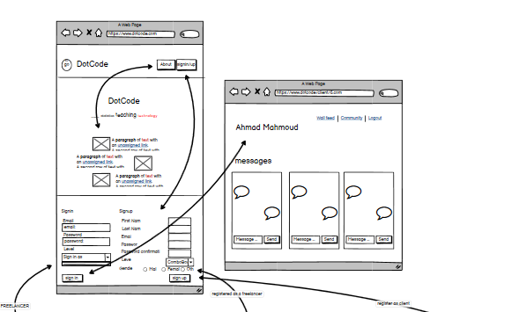

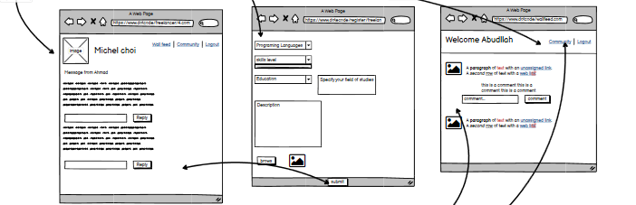

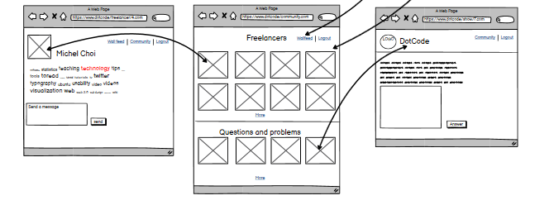

**3- Chapter Three: ERD**

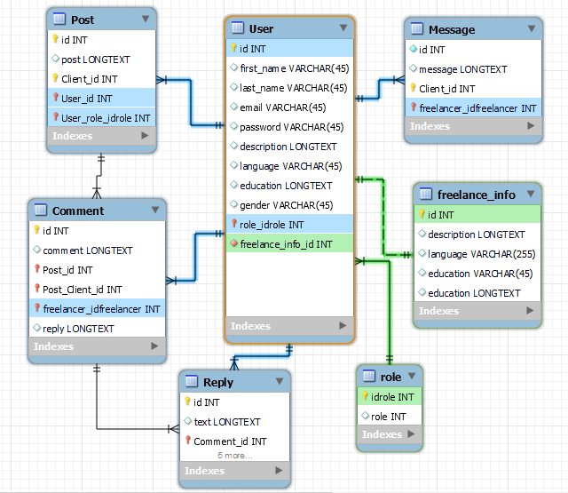

**Group members: Supervisors:**

Abdullah Qasem Saad Hroub

Ahamad Mahmoud Amin Eid

Lana Theodory